IBM Confidential

IBM Consulting

FutureNow Center, Philippines

Records Management

Policy and Requirements
Version:
7.0

Status: Approved

The official version of this document is stored in Cobee Lite. Any hard copy versions of this document are for REFERENCE ONLY. Users of this document are personally responsible for using official version, and for verifying that any copies are complete and of the official version.

NOTE: No IBM or Client Personal Information/Sensitive PersonaI Information should be included in this document.

Table of Contents

1 Document Information 4
1.1 About this Document 4
1.2 Scope and Applicability 4
1.3 Revision/Approval History 4
1.4 References 6
• Section 7.5 Documented Information - Control of Documented Information 6
• Worldwide Records Management 7
1.5 Distribution 7
1.6 Document Control Information 7
2 Introduction 7
2.1 Introduction to the Records Management Process 7
2.2 Handling IBM Information 7
3 Records Classification and Retention 8
3.1 Types of IBM Information 8
3.2 Non-IBM Information and Information of Acquired Companies 8
3.3 Document Retention Requirements 8
4 Roles and Responsibilities 9
4.1 Records Management Roles and Responsibilities 9
5 Records Management Requirements and Guidelines 10
5.1 Records Management Lifecycle Management 10
5.2 Storage and Organization 10
5.3 Records Matrix Management 12
5.4 Disposal Methods 12
6 Governance and Controls 13
6.1 Records Matrix Review and Approval 13
6.2 Process Measurement 13
6.3 Risk Incident Management and Handling 14
7 Definitions 14
8 Appendices 14
8.1 Identification and Classification of Records 14
8.2 Storage of Essential Information 14
8.3 Review of Records Disposal 15
8.4 Older/CD Guidelines 15

Document Information

About this Document

This document outlines the Records Management Policy governed and managed by the Quality Management System Team.

Scope and Applicability

This document is intended for individuals who manage or execute the Records Management Process within IBM Consulting FutureNow Center Philippines, and for anyone requiring information or training related to the process.

Revision/Approval History
Revision History from version 1 to 15 already redacted from previous document repository tool (QMX).

Version Number | Effective Date | Summary of Changes | Author (Name and Role) | Approver (Name and Role)
7.0 | 4-Aug-2026 | Minor changes:  - Updated the template’s sections to standardize across all policy documents.  - Updated Sections 1.4 and 5.3 to indicate that Records Matrix Template is stored in Digital Controls Center (monday.com board | Michaella Gail Santiago  Quality Process Lead | Oz Rancudo  BCP & QMS Leader
6.0 | 4-May-2026 | - Rebranded and updated scope from IBM CIC Philippines to IBM Consulting, FutureNow Center Philippines.  Document structure significantly expanded and reorganized (added formal Table of Contents and re-sequenced sections into a full policy format).  Added Distribution and Document Control Information sections.  Added/expanded Introduction and IBM information-handling guidance.  Expanded Records Classification & Retention content.  Roles & Responsibilities were rewritten and broadened.  Storage & organization guidance greatly enhanced.  Disposal guidance expanded and clarified.  Definitions streamlined.  Appendices were reorganized/redistributed.  References refreshed and refocused. | Michaella Gail Santiago  Quality Process Lead | Oz Rancudo  BCP & QMS Leader
5.0 | 19-Sep-2025 | Upon alignment with Business Controls Team:  - Removed item 7 under section 3 (sample records listing) to empower teams in assessing their records retention requirements.  - Updated Section 5.2 Internal Key Control with the updated IKC 6.4 requirements, including the use of the Global Records Retention Tracker. | Michaella Gail Santiago  Quality Process Lead | Oz Rancudo  BCP & QMS Leader
4.0 | 22-Jul-2025 | - Updated version number to match the Cobee Lite narrative number.  - Updated links to: Corporate Instruction DG101 Data Governance (formerly CIO122) and IBM Global Quality Framework (ISO 9001:2015 Standards Guidance) under Section 1.4 References. | Michaella Gail Santiago  Quality Process Lead | Oz Rancudo  BCP & QMS Leader
23 | 9-Jan-2025 | - Updated Item 6 under Section 3 to indicate center-recommended retention period for reference records.  - Updated Item 7 under Section 3 for better guidance regarding the Records Matrix Table.  - Updated Records Matrix table with current list of documents and record codes.  - Updated Records Matrix Template and link to download.  - Updated Box Label guide and link to download. | Michaella Gail Santiago  Quality Process Lead | Oz Rancudo  BCP & QMS Leader
22 | 2-Sep-2024 | Added link to DG101 in References (formerly CIO122)  Updated definitions for Essential, Reference, and Disposable records.  Added Document Retention Orders (DROs) to Types of IBM Information.  Added Section 5.2 Internal Key Control 6.4 for Records Retention Plan. | Michaella Gail Santiago  Quality Process Lead | Oz Rancudo  BCP & QMS Leader
21 | 21-Jun-2024 | Updated links to the IBM WWRM and GQF  Replaced QMX with Cobee Lite  Renamed T&T Tower to TT Tower  Renamed F&A IPS Tower to FSCT  Replaced Business Center team with GRE Team  Updated email address of QMS Team to the Delivery Operations functional email address  Updated link to Data Incident Reporting. | Michaella Gail Santiago  Quality Process Lead | Oz Rancudo  BCP & QMS Leader
20 | 4-Jul-2023 | Minor change: Updated Section 5.1 Records Management RISC Scorecard per update from RISC Team. | Michaella Gail Santiago  Quality Process Lead | Oz Rancudo  BCP & QMS Leader
19 | 1-Aug-2022 | Minor change: Updated Records Matrix Table under Section 3 to include Retention Code for Policy Documents. | Michaella Gail Santiago  Quality Process Lead | Oz Rancudo  BCP & QMS Leader
18 | 27-Jun-2022 | Major change: Update table under Section 3.0: Examples of documents' Retention Codes and Periods Record owners. | Michaella Gail Santiago  Quality Process Lead | Oz Rancudo  BCP & QMS Leader
17 | 22-Dec-2021 | Minor change: Updated link to incident handling process under Section 8.5. | Michaella Gail Santiago  Quality Process Lead | Oz Rancudo  BCP & QMS Leader
16 | 13-Jan-2021 | Minor Change: Removed this note under Section 8.2 since there is no more KCO Testing for Records Management. | Michaella Gail Santiago  Quality Process Lead | Oz Rancudo  BCP & QMS Leader

References

Standards:
- ISO 9001:2015 Standards Guidance
- Section 7.5 Documented Information - Control of Documented Information
- Worldwide Records Management
Center Tools & Templates:
- Records Matrix Template stored in Digital Controls Center (monday.com board)

Distribution

This document is available in the Cobee Lite tool. Employees can access the official version on the QMS Publisher page.

Document Control Information

At the end of this document is a labeled box indicating the end of text.

END OF DOCUMENT.
IBM FNC PH – Records Management
Policy and Requirements
Version 7.0

Introduction

Introduction to the Records Management Process

The Records Management process is established in alignment with IBM's Worldwide Records Management Plan and ISO 9001:2015 requirements to ensure the effective creation, capture, classification, retention, protection, retrieval, and disposal of records in a controlled, compliant, and auditable manner.
This process safeguards IBM's business interests and regulatory obligations by ensuring that records generated and maintained by accounts and teams within the IBM Consulting FutureNow Center Philippines are properly managed throughout their lifecycle, supporting operational integrity, accountability, and audit readiness.

Handling IBM Information

All IBM units, subsidiaries, and legal entities worldwide must comply with Data Governance Corporate Instruction DG 101 for the retention and disposal of information. These requirements apply to all formats and media, including physical records, electronic communications, collaboration platforms, social media, and business applications. Retention is determined by the content of the record, regardless of where it is created or stored.

Records Classification and Retention

Types of IBM Information

Essential information is that which needs to be retained for a defined period to satisfy legal, regulatory and business requirements. Must be retained for a period that enables IBM to meet its business needs, as well as legal, regulatory, and tax obligations. Each type of Essential information and its required retention period is defined in the WRM under Essential information categories, record codes, and retention periods.
See appendix for more information on storing Essential Information.
Reference information is that which needs to be retained by the user to perform their work but has no defined retention period. It should be retained only as long as necessary to satisfy business needs. It must: be reviewed regularly for continued business needs; and clearly identify the information owner.
Disposable information is that which is neither Essential nor Reference; it should be disposed of promptly and in accordance with security requirements based on the security classification of the information. Information is considered Disposable if it:
- is not classified as Essential or Reference, and
- is not subject to a Document Retention Order.
Such information should be disposed of immediately.

Non-IBM Information and Information of Acquired Companies

Information owners are responsible for retaining and disposing of their records.
- Records from customers, vendors, or business partners must be managed according to contractual requirements or their instructions, when allowed by IBM policy and business needs.
- Records from acquired companies follow IBM's records management policies and retention periods unless the acquisition terms specify otherwise.
- Any document retention orders in place before the acquisition, as well as all IBM DROs, remain in effect until IBM Legal states otherwise.

Document Retention Requirements
Document Retention Orders (DROs) are notices from IBM Corporate Litigation, IBM Investigations, and other IBM Legal groups that require certain information to be preserved for legal purposes.
Key points:
- A DRO pauses normal WRM retention rules until it is lifted.
- It may apply to Essential, Reference, or Disposable information, entire record categories, specific subjects within a category, or data in databases, repositories, or platforms.
For more information on DRO, please see the relevant IBM Legal link.

Roles and Responsibilities

Records Management Roles and Responsibilities

All IBM employees and contractors are required to comply with the procedures described in this policy document.
1. Information Owner must keep Essential information readable and recoverable for the full retention period.
- May be the record's creator, a recipient, or a delegated third party.
- Ownership is generally based on who needs the record for business, legal, or audit purposes.
- If unclear, the involved parties should decide ownership together.
- Anyone who is not the information owner holds only Reference copies of the record.
2. Managers must assign responsibility for implementing and maintaining information retention practices and ensuring compliance with this instruction.
- They must ensure continuity of retention practices during personnel changes; departing employees' Essential, Reference, and Disposable records must be handled per DG101 and this document.
- They should also ensure this document, including any local updates, is accessible to all staff and support teams who manage information on their behalf.
3. Record Code Owners are listed for each Essential information category in the WRM plan and are responsible for:
- Helping Business Process Owners confirm all Essential records in their category are correctly identified and assigned the right retention requirements.
- Providing expertise and guidance to information owners and other WRM users on the records in their category.
- Reviewing all proposed category changes, assessing impacts (including to Country Variants), and obtaining legal input when needed.
- Submitting vetted change requests to the WRM Records Management Program Manager.
Transition policy:
- A Record Code Owner who expects to change roles must identify a replacement and submit a change request to the WRM Records Management Program Manager.
- If the owner leaves IBM without naming a successor, their manager must appoint one and submit the change request.

Records Management Requirements and Guidelines

Records Management Lifecycle Management

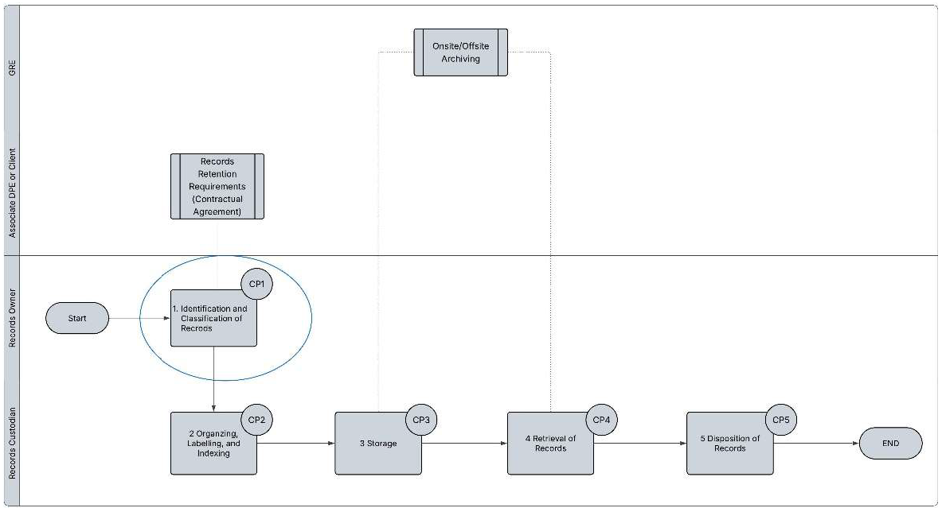

Storage and Organization

Types of Storage
Managers may use onsite or offsite storage and should deliberately choose between them. Onsite storage offers easier access but limited space; offsite storage provides more capacity but slower retrieval.
Managers may keep records onsite for a period and later move them offsite, if total retention requirements are met. Frequently accessed records - often those less than one year old - are typically better kept onsite, while older records may be stored offsite.
Legal and contractual limits must also be considered, especially for client-owned records. IBM-owned records can be stored offsite at the Manager's discretion, but client-owned records require contractual approval or written client instructions before offsite storage is used.

Onsite storage
- Onsite records must be clearly labelled with filenames, record series codes, and retention dates.
- They must be stored in secured cabinets or drawers.
- Records owners are responsible for keeping these documents safe, accessible, and retrievable.

Offsite storage
- Offsite storage is generally not allowed for client-owned records unless contractually agreed or explicitly approved by the client.
- Offsite storage is managed by the GRE Helpdesk through a separate process with its own forms and approvals, designed to ensure efficient retrieval.
- Use of the Archive Listing and Disposal Authorization Template is recommended to track all records sent offsite through final destruction.
- Department managers may approve transfers of inactive records or require records to stay onsite longer for business needs.
- Accredited IBM FutureNow Center Philippines vendors are authorized to safeguard IBM information in all media.
- The GRE Helpdesk handles all archiving requests and sends records directly to the archiving vendor; IBM FutureNow Center Philippines sites serve only as temporary staging areas.
- Retrieval requests must be routed through the GRE Helpdesk, who will coordinate with the vendor.

Non-local / external repositories

IBM FutureNow Center Philippines may share IBM's Global Records Management Policy with external service providers, but those providers remain fully responsible for preventing loss or breaches of IBM FutureNow Center Philippines information.

A. IBM client and IBM Global hosted repositories
- Records stored in client-hosted or IBM Global repositories are outside the scope of IBM FutureNow Center Philippines Records Management. Their administrators are responsible for managing and protecting them.
- Any records downloaded or modified locally must be added to the account or process records matrix.

B. Outsourced IBM services and information
- IBM service providers must protect all IBM information they handle.
- Their responsibilities include record inventory, security, storage, and proper disposal or return of records to IBM FutureNow Center Philippines as specified in the agreement.

Organizing, Labelling, and Indexing
It is the responsibility of the Manager to organize the records in the manner that will allow them to identify and retrieve records effectively and efficiently. Appropriate Indexing should be applied depending on the anticipated retrieval process. Indexing which will also be reflected in the labels of the folders/binders may be based on per date, per type of employee, per region/country, etc.
A label is considered accurate if it contains basic record information such as record code, filename, coverage date, computed end of retention periods, and data classification. Specific labelling instructions should also be considered per type of records classification.

Labelling
For box/container labels, it should include a box code that reflects the correct disposal date (month and year translated into four-digit numbers, e.g. 1026 for October 2026). The disposal date should be based on the latest retention period of the records placed in the box (e.g., if there are 3 folders inside the box, having retention period of 1, 2, and 3 years, the disposal date reflected in the box should be based on 3 years). It is still advised for the record custodian to review the archive listing at least once a year, to review records that may need to be disposed already.
Box code labels should be according to the IBM Consulting FNC Philippines box label guide.
Note: For Accounts/Projects, Country, Process/Domain not included in the Operations Codes (2) Tab, reach out to cic.ph.delivery.operations@ibm.com for assistance.

Records Matrix Management

Records Matrices are stored in the Digital Controls Center monday.com board managed by the Business Controls Team. Records Matrices are subject to annual review and approval, which must be completed by March 31.

Disposal Methods

Confidential Information
- Must be disposed of following IBM Security guidelines and local RESO rules.
- See Corporate Instruction LEG 116 for detailed requirements.
- Check your local Workplaces@IBM page for approved confidential waste bins, shredders, or secure disposal options.

Electronic Information
- Electronically stored information on IBM systems must be securely deleted, overwritten, or destroyed along with the physical media to prevent data recovery.

Information Stored Off-Site
- Off-site records must be destroyed by IBM's authorized storage vendor once their retention period ends, unless they are under a Document Retention Order, in which case they must be kept until the order is lifted.

View exceptions to Standard Disposal here.

Governance and Controls

Records Matrix Review and Approval

Records matrices should be reviewed and approved annually. Refer to this table for the recommended approvers per tower.

Talent Transformation | Finance and Supply Chain Transformation | Shared Services | Center Support | Other Towers
HR Delivery Manager  and  CSM | Team Lead/Operations Lead  and  Operations Manager | Team Lead/Operations Lead  and  Domain Lead (or its equivalent/delegate) | Team Lead/Manager  and  Manager/Center Leader (or its equivalent/delegate) | Team Lead  and  Operations Manager (or its equivalent/delegate)

Process Measurement

Records Management RISC Scorecard

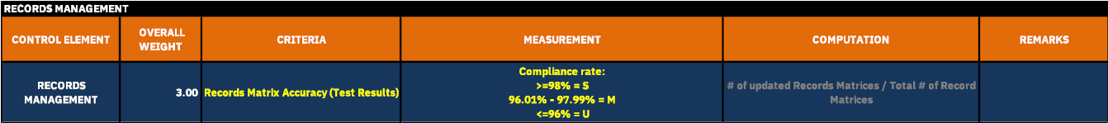

Internal Key Controls

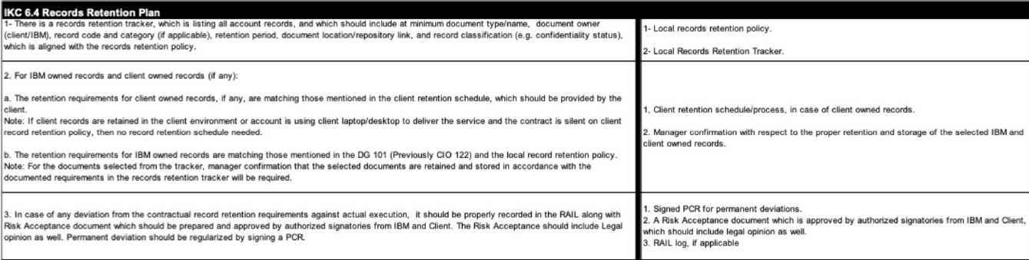

Risk Incident Management and Handling

Risk and unforeseen circumstances are always present in day-to-day business operations. All teams should be aware and explicitly state that they know, understand, and accept risks involved in storing records regardless of volume and location.
Should there be an incident regarding loss of records, please refer to the relevant link for risk and incident handling process

Definitions

Term | Definition
IBM WRM/WWRM | IBM Worldwide Records Management
QMS | Quality Management System Team
ISO | Internal Organization for Standardization
Retention Period | Period that defines the life cycle of the record from creation, transfer to archive, to obsolescence stage.

Appendices

Identification and Classification of Records

It is the responsibility of records owner to identify which records are to be retained. This may be based on how records are classified in accordance with IBM or Client Requirements.
- Classification of records should also be considered in accordance with IBM, for IBM owned records, or Client's, for client owned records.
- For TT and FSCT, records matrices should cover all records in a consolidated file per account (Ex. One records matrix per account).
- For Shared Services, Center Support and other towers, records matrices should cover all records retained per process/domain.

Storage of Essential Information

All Records:
Accessibility and Usability
- Information must stay retrievable and usable for the full retention period.
- Information owners must choose suitable media, formats, and repositories for storing Essential records based on their nature and required retention duration.
Secured Essential Information
- If Essential records are locked, encrypted, or otherwise secured, access must be maintained for the entire retention period.
Repository Preference
- Essential information should be stored in shared repositories rather than personal or individual locations whenever possible.

Review of Records Disposal

All retained records must be checked annually and disposed accordingly, based on IBM's requirements (for IBM owned records), or client's requirements (based on contractual agreement). If the client did not provide the needed specifics on the records retention schedule, then IBM Policy should be applied.
For the annual review, the actual records stored on-site (including those that are in laterals, pedestals, and on-site storage facility rooms) and the Archive Listing should be reviewed together.
Records matrices are to be reviewed, updated (if applicable), uploaded, and approved in the document repository (Cobee Lite). This will ensure up to date list of records types stored by all teams and groups. It should be reviewed annually. Measures, criteria, and reporting are covered in the Records Management System.
Hold Orders - In some cases, the normal retention, storage, and destruction of information are superseded and it is the clients responsibility in communicating through the account management or delivery teams (PMO, PE, CSM, etc.). All normal records destruction (of essential, reference and disposable records) must be suspended if IBM Legal issues a hold/suspend order for the records in question.
See: Essential Information categories, record codes, and retention periods.

Older/CD Guidelines

Labels should at least reflect the information below, to allow effective identification and retrieval. All other indexing information relevant to Records Owner may also be included in the label (per employee type, date/month/year, etc.).
Following information is shown on the Record Labeling Guide:
- Records Name/s
- Records Code (if applicable)
- Retention Period
- Data Classification

END OF DOCUMENT.
IBM FNC PH – Records Management
Policy and Requirements
Version 7.0

